COVID-19 community risk levels

2022-08-16

# The impact of supperpassed on risk level calculation

Based on HealthData.gov, Suppression is applied to the values with sums and averages less than four (4). In these cases, the field is replaced with “-999,999”. In our study, we replaced the suppression values with a randomly selected number between 1, 2, or 3 and then calculated the risk level. The following plots applied three other methods for replacing “suppression” to see how they affect the risk level.

## suppressed = random between (1, 2, 3)

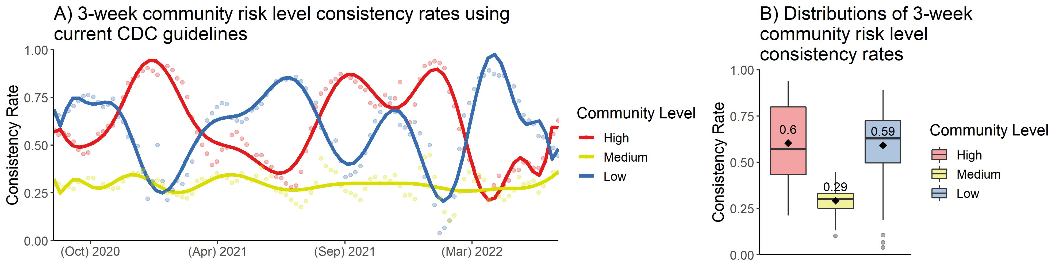

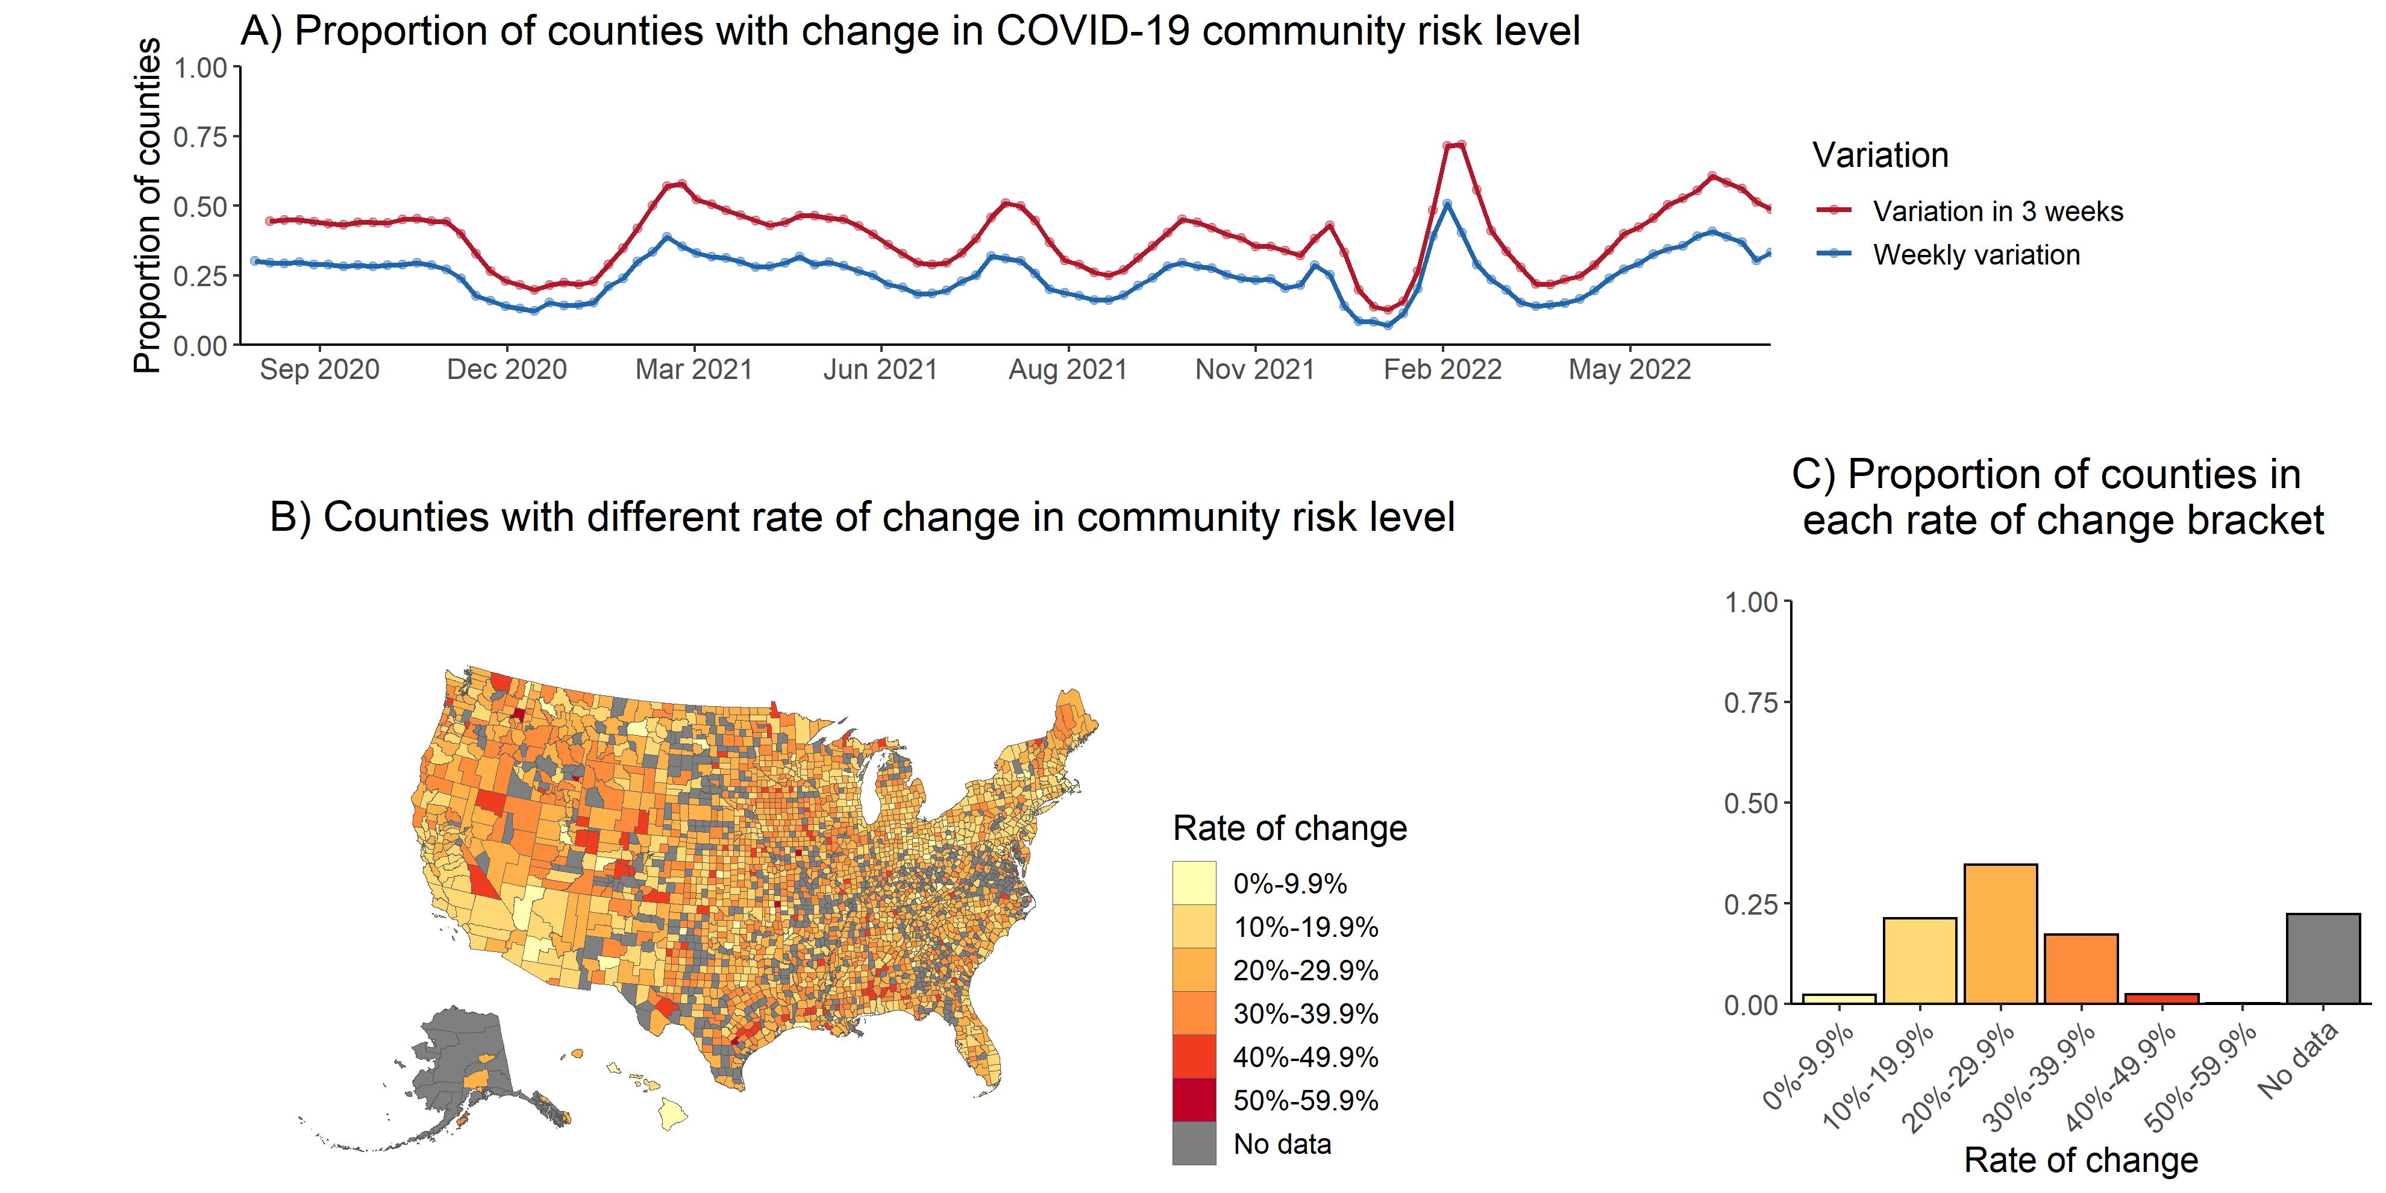

## 1. suppressed = 1

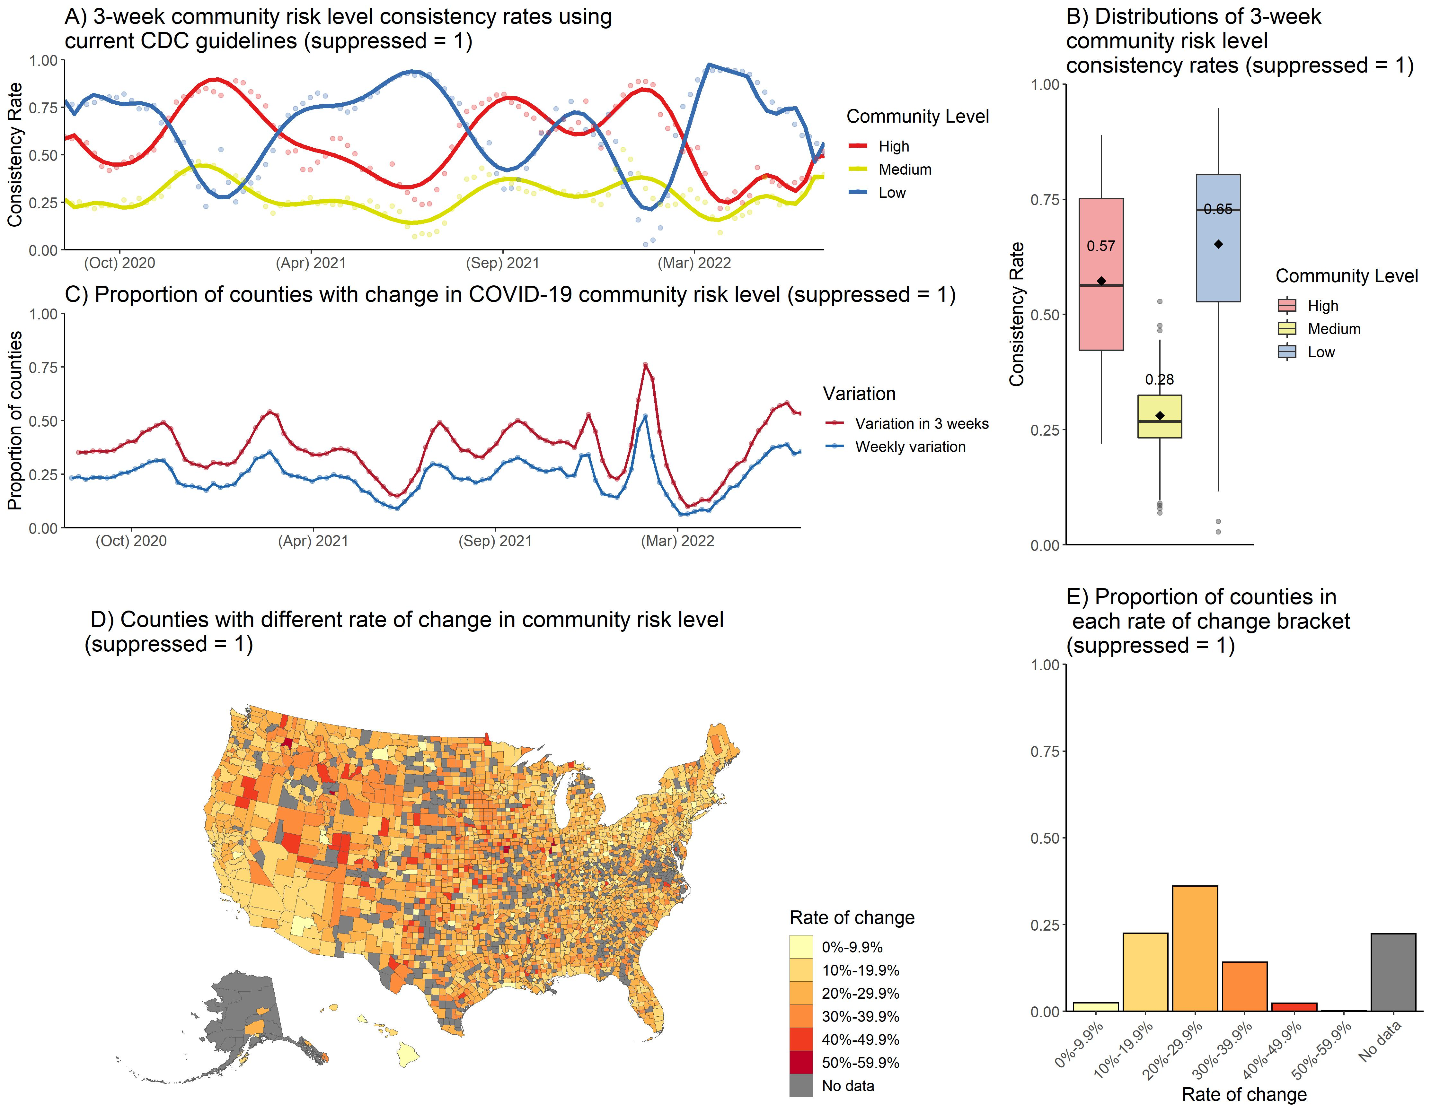

## 2. suppressed = 3

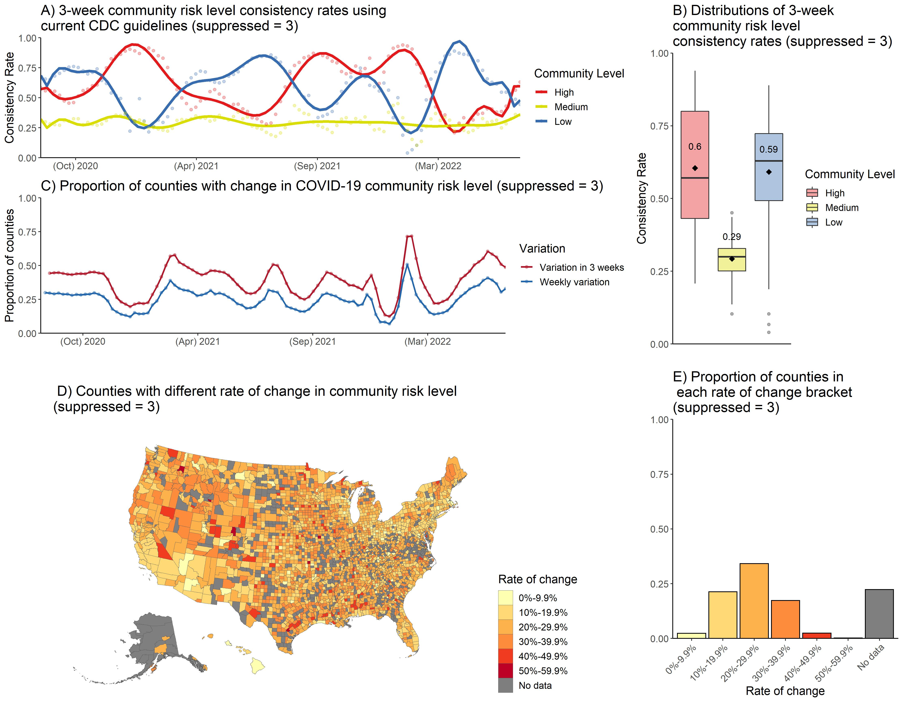

### 3. suppressed = NA

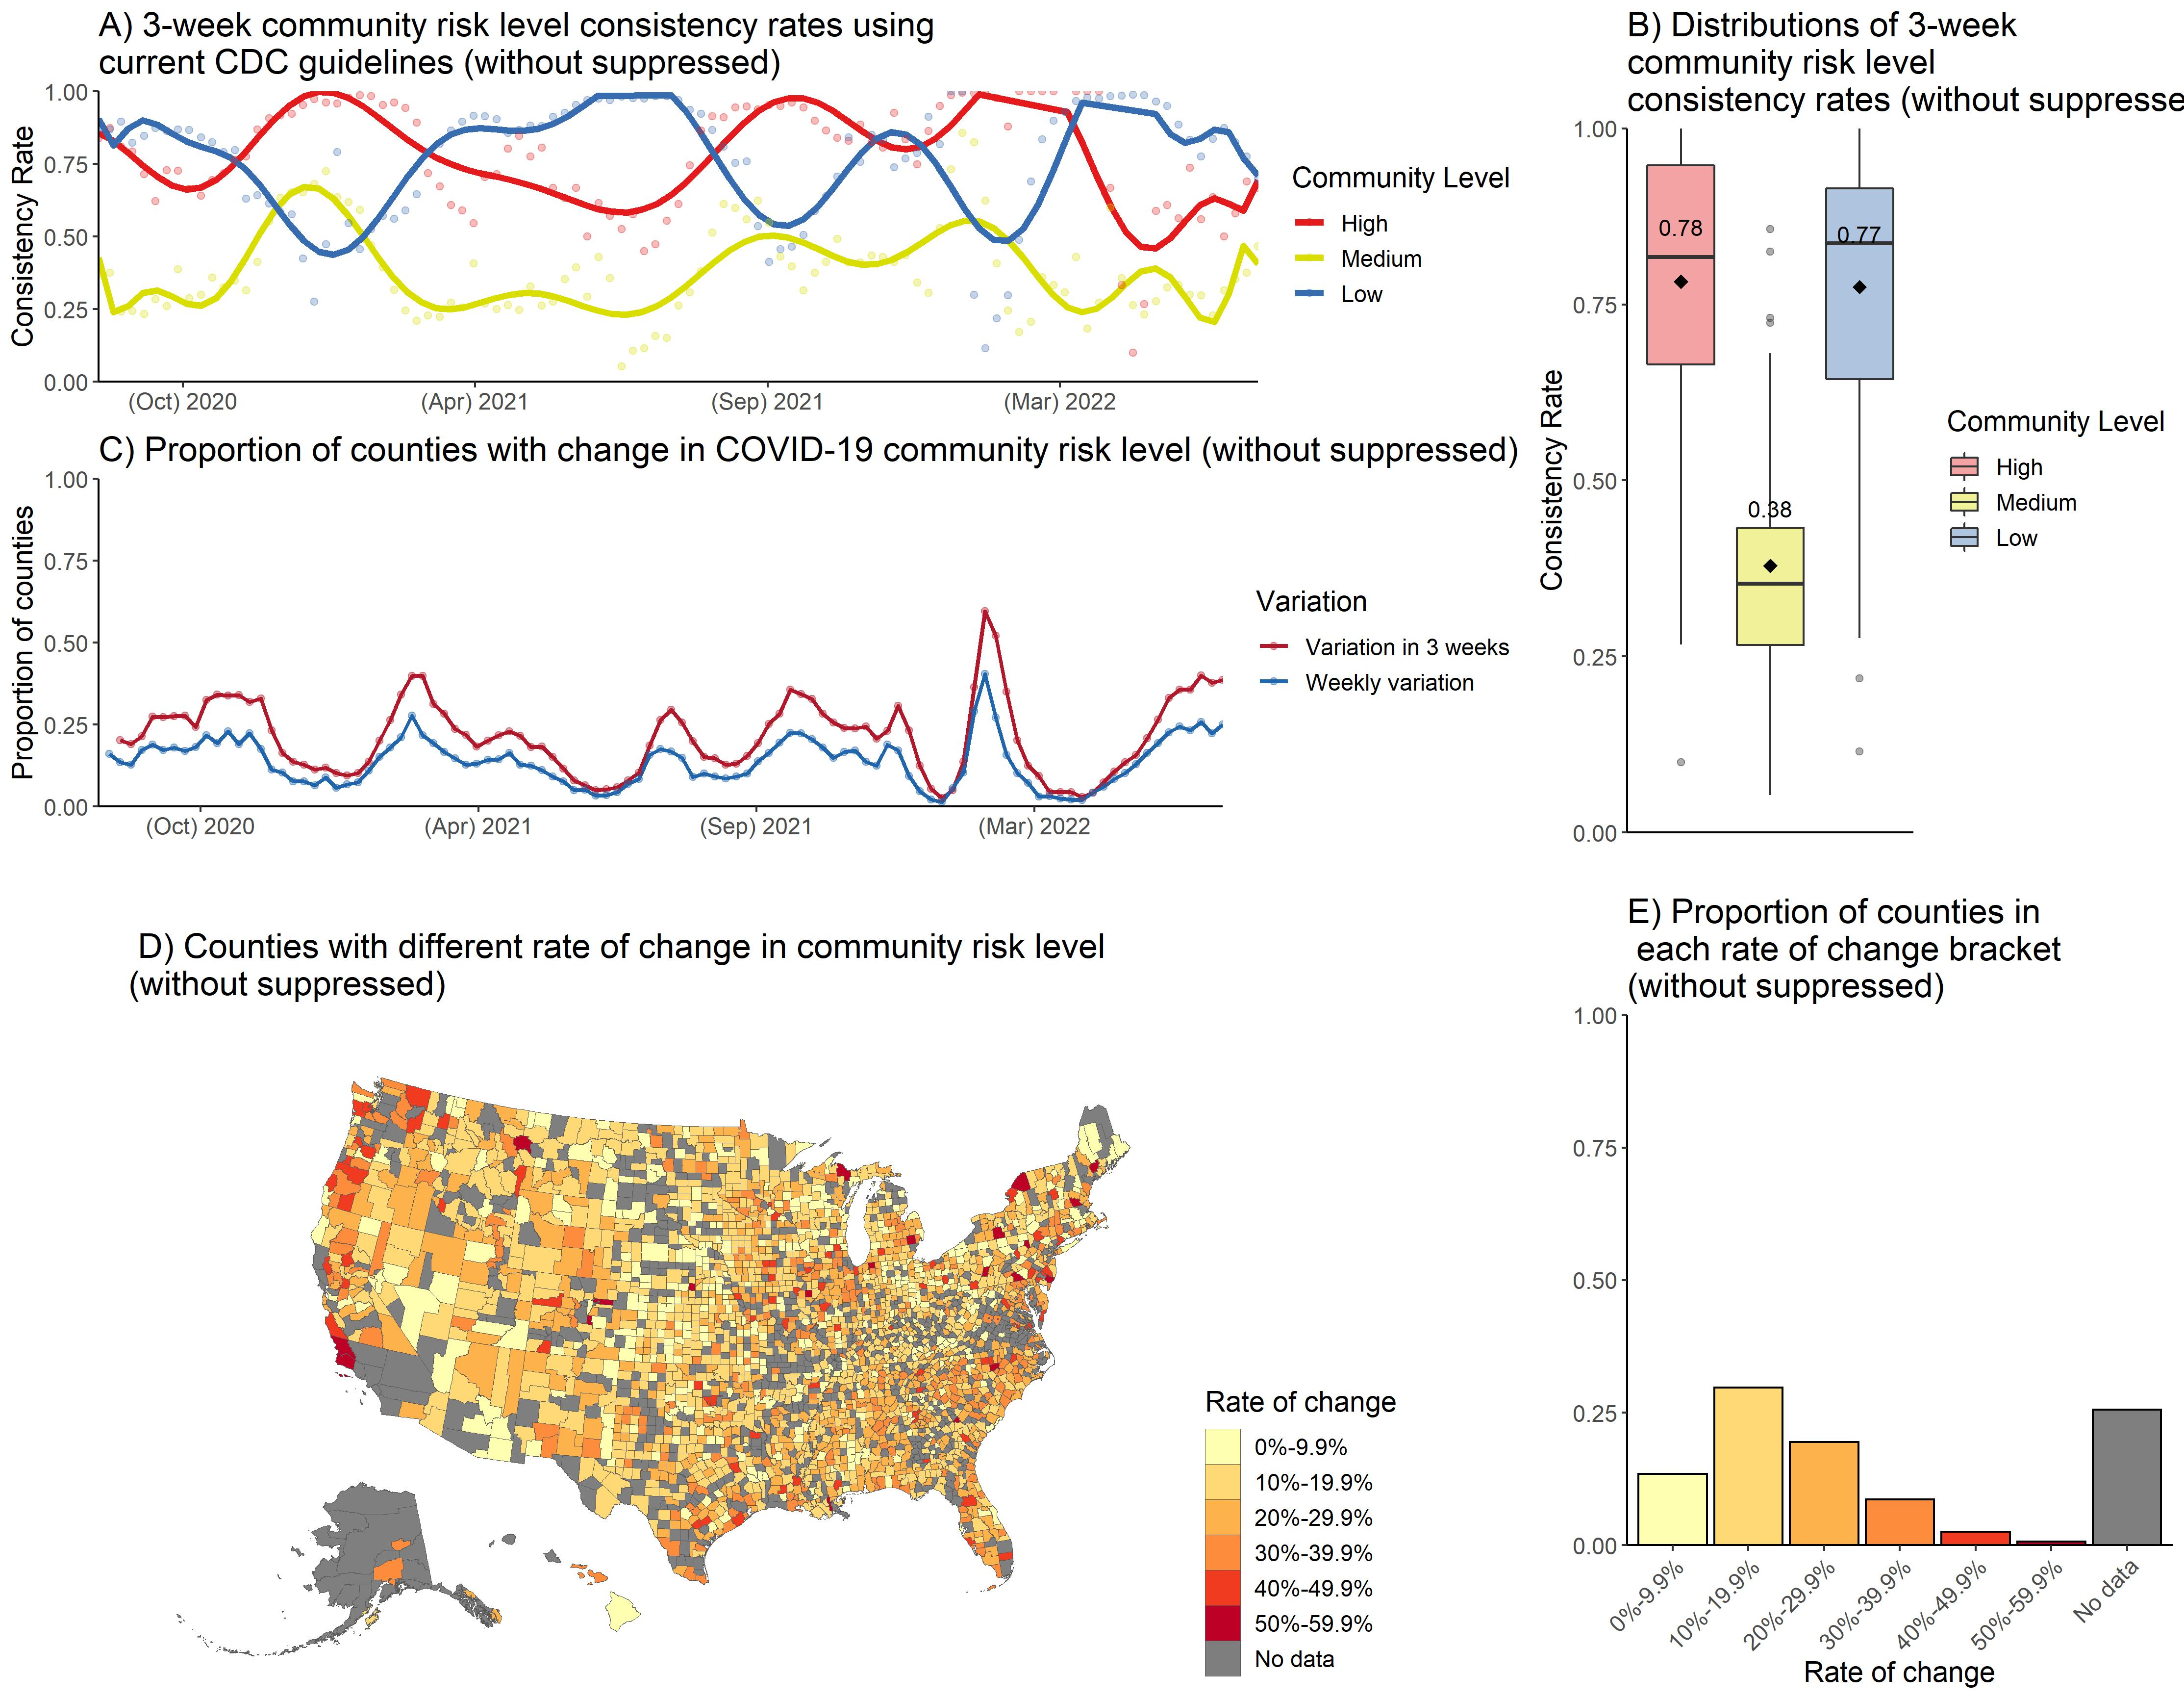

We have almost the same risk level when suppression = three and suppression = random number. The mean consistency rate in counties with high-risk level decrease, and in counties with low-risk level increase when we set suppression = one. However, if we remove suppressed data, the mean consistency rate increase in counties with low, medium, and high risk levels.

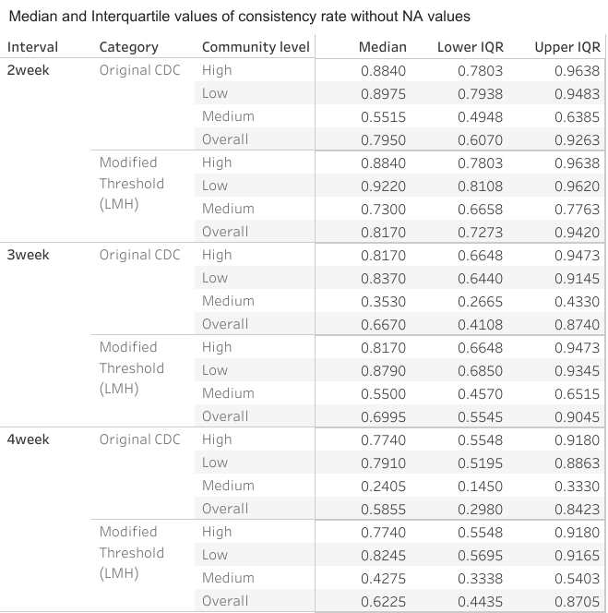

# Consistency results for urban counties and rural counties separately.

We use National Center for Health Statistics (NCHS) data systems to study the associations between the urbanization level of the residents. NCHS has developed a six-level urban-rural classification scheme for U.S. counties. The most urban category consists of “central” counties of large metropolitan areas, and the most rural category consists of nonmetropolitan “noncore” counties.

### 2013 Urban-Rural Classification Scheme for U.S Counties

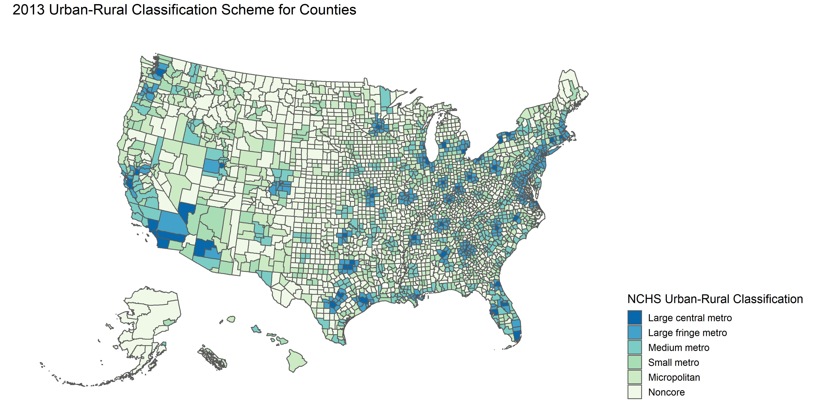

# The rate of change in different NCHS Urban-Rural Category

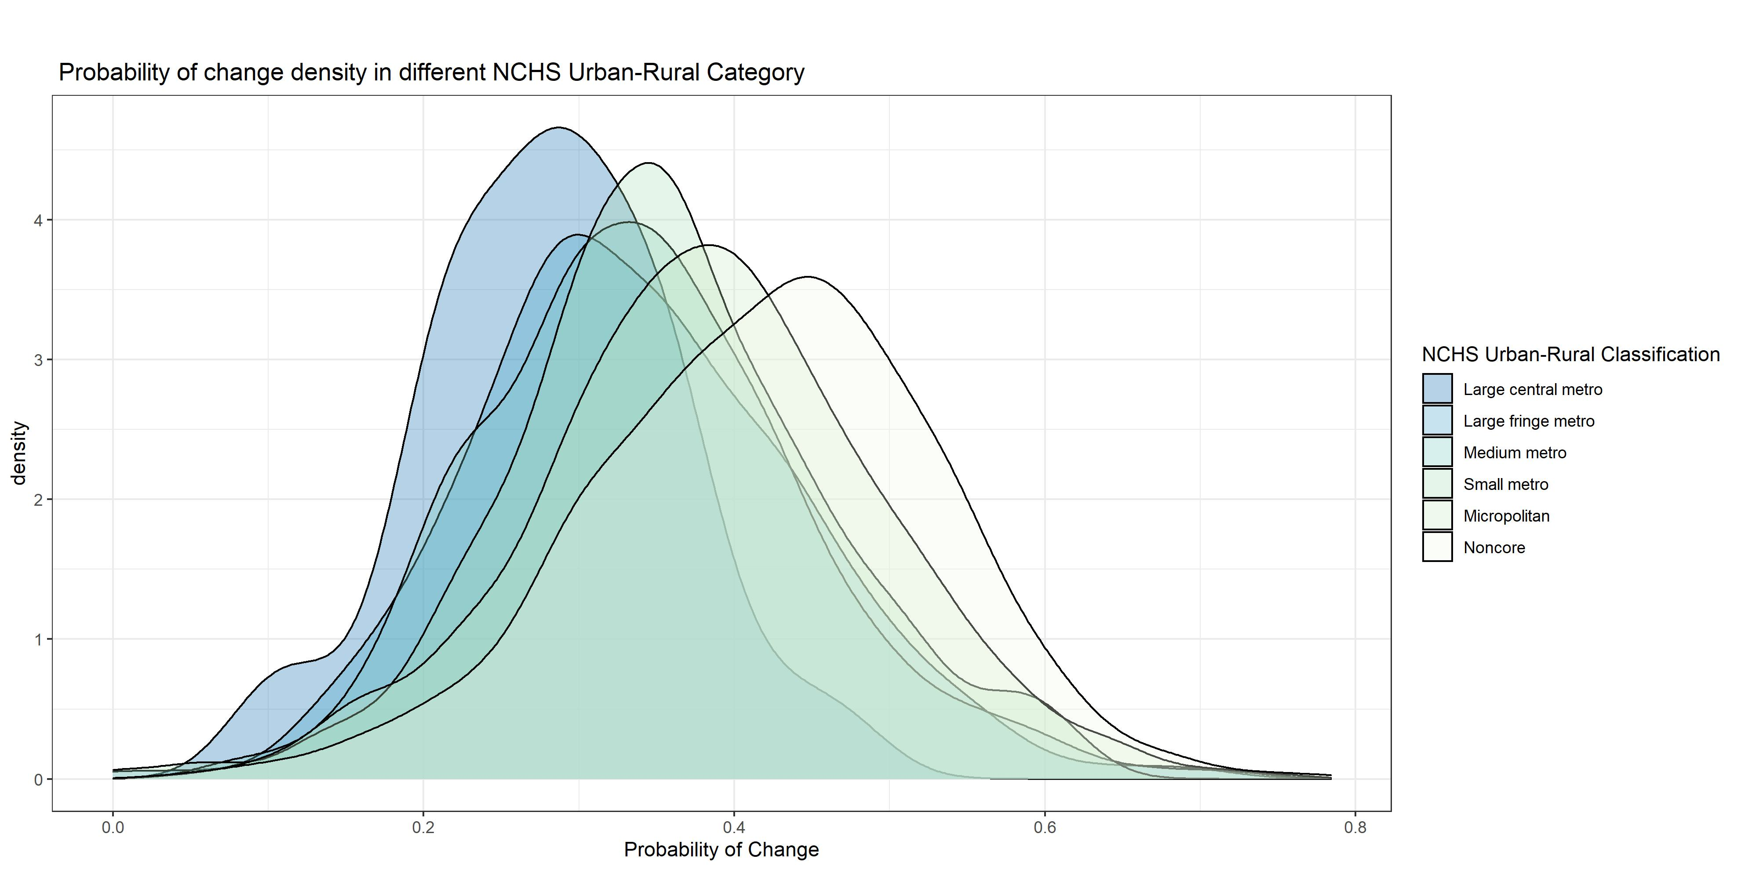

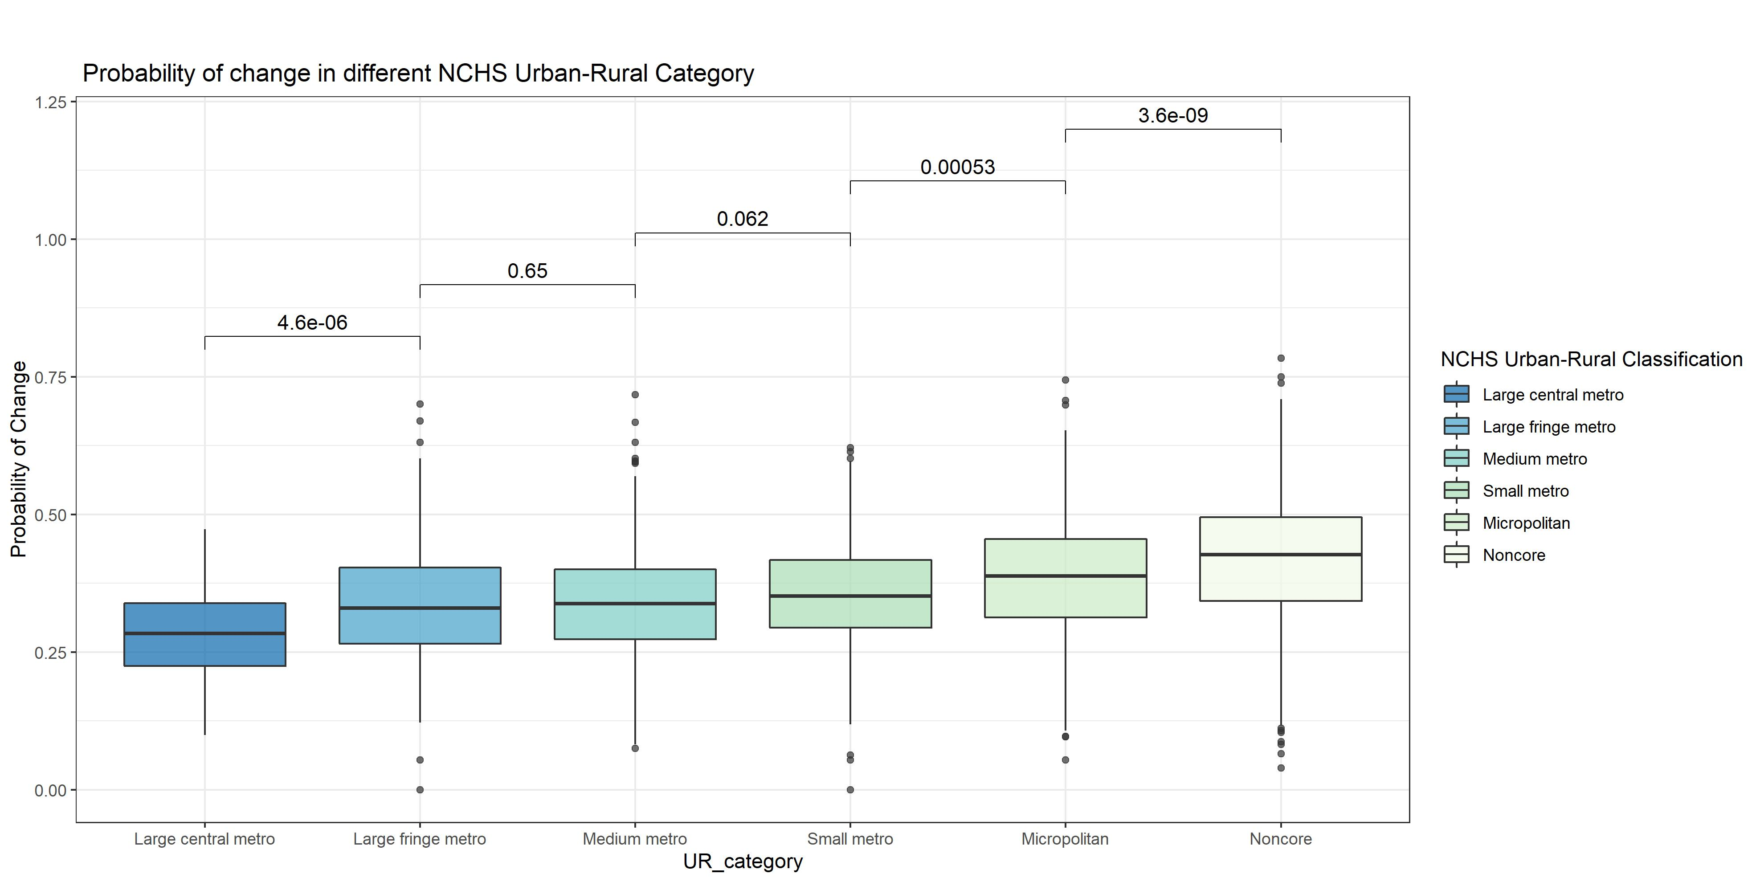

We use a t-test and p-value to compare the means of the rate of change in each NCHS group. The counties with more urbanization levels have a lower rate of change than counties with lower urbanization levels. However, this difference is not significant in all NCHS categories.

# The association between the rural population percentage and the rate of change in community risk level

The 2010 Census Urban and Rural Classification dataset has been used for the following analysis. Also, we used the “Pearson” method to add correlation coefficients and p-values to scatter plots.

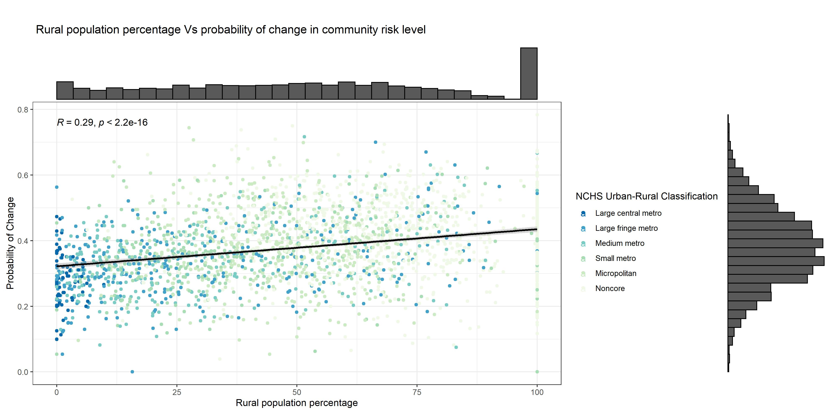

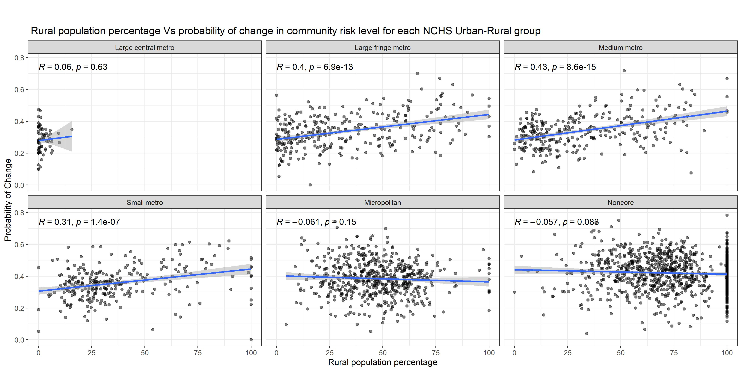

There is a positive correlation (R = 0.3) between rural population percentage and the rate of change in risk level in counties. So Increasing the county’s rural population percentage also increases the rate of change. However, this correlation is not significant in all NCHS Urban-Rural groups.

# The association between the county population and the rate of change in community risk level

The 2020 American Community Survey (ACS) counties population has been used for the following analysis.

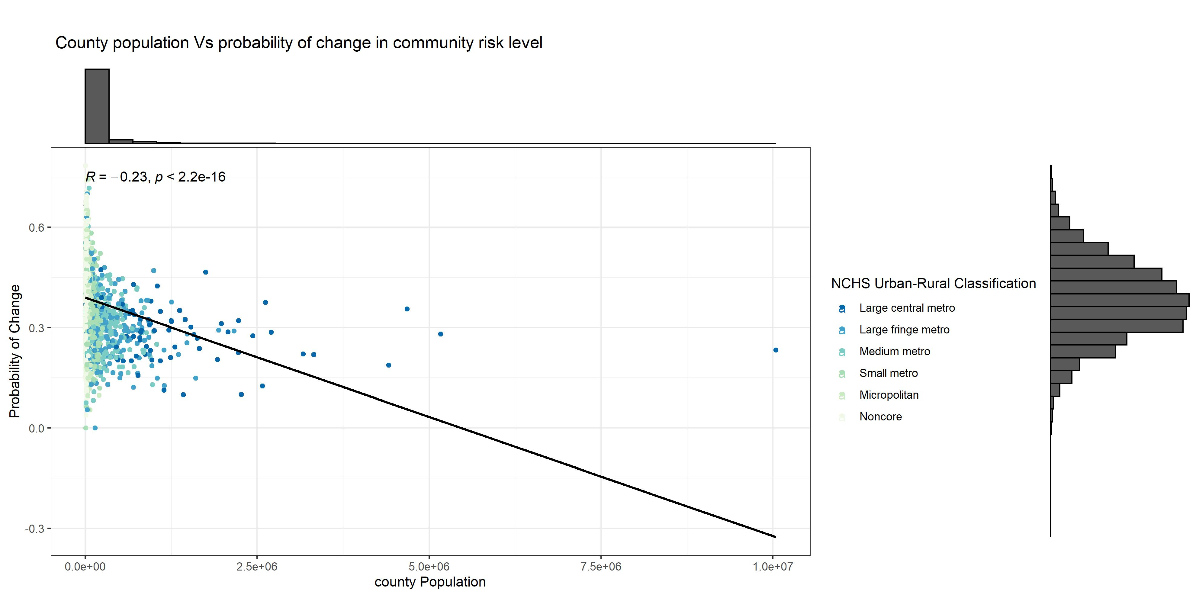

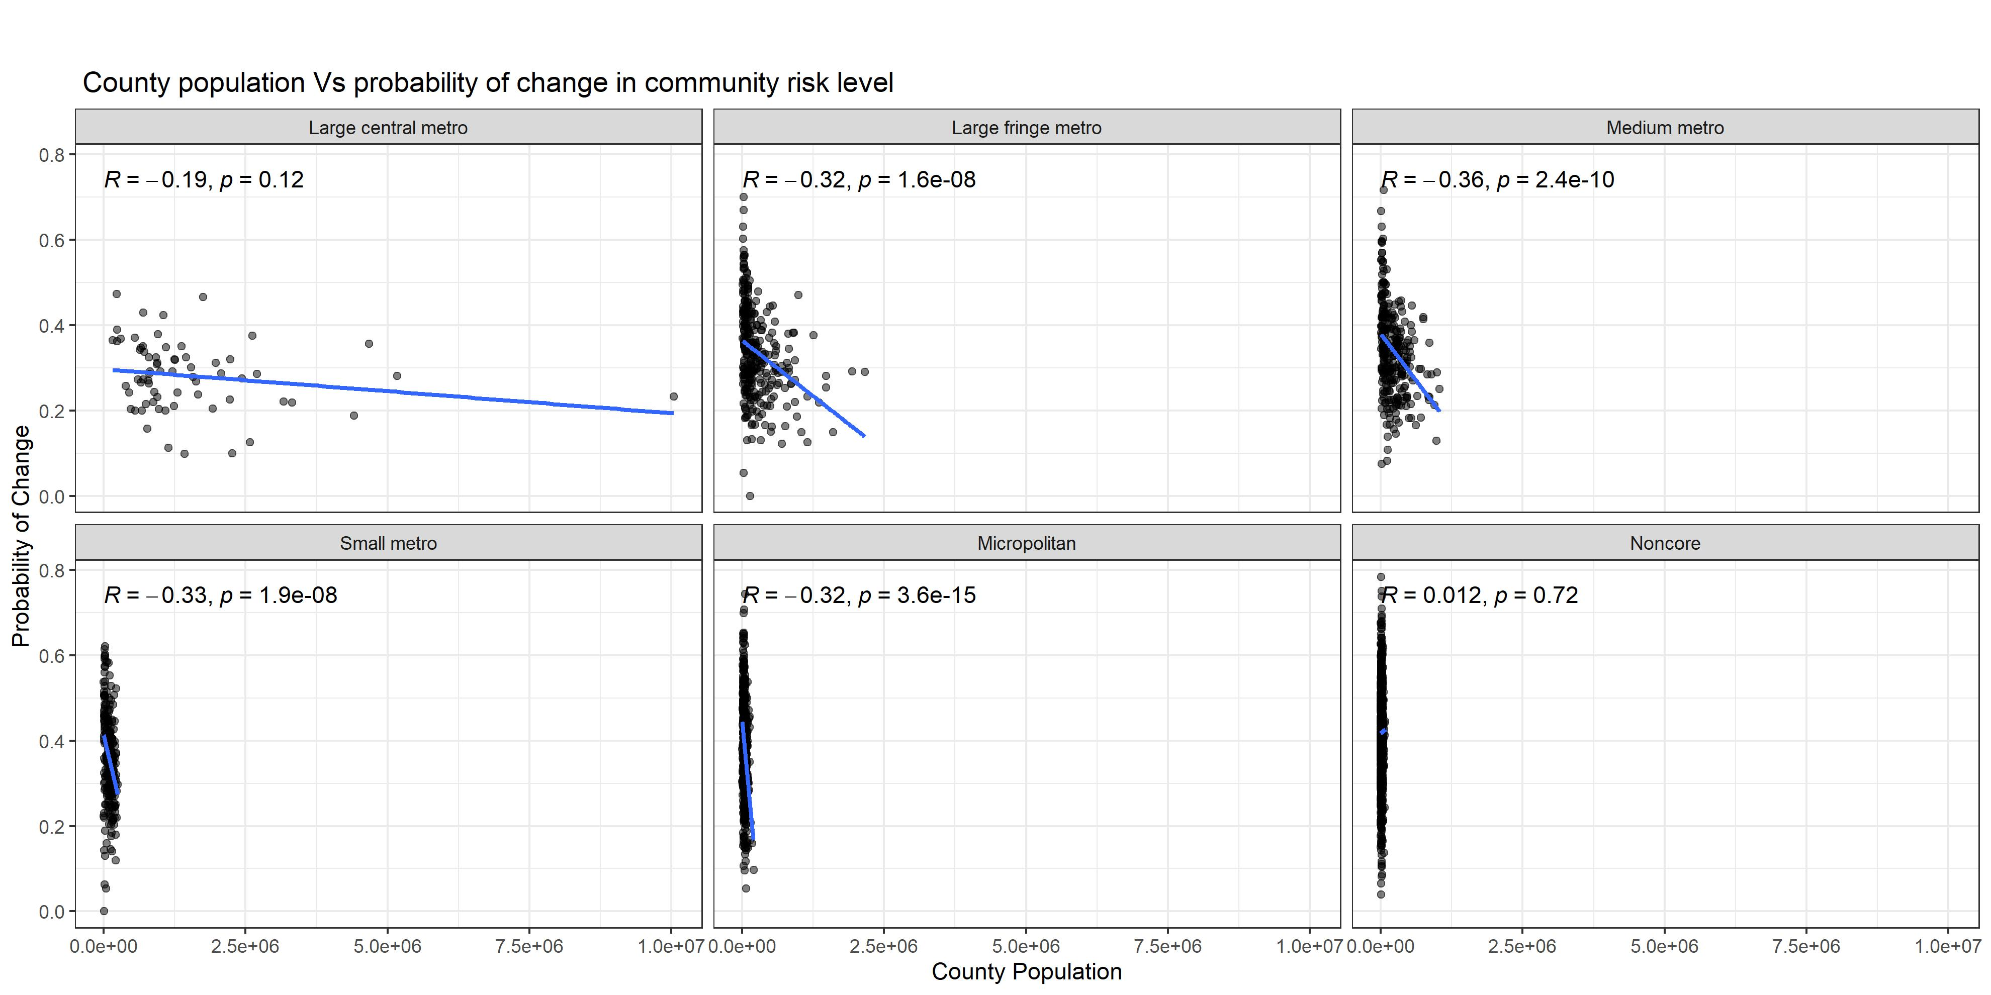

Because the population data is skewed distributed, we use log transformation for the population.

# The association between the Log of population and the rate of change in community risk level

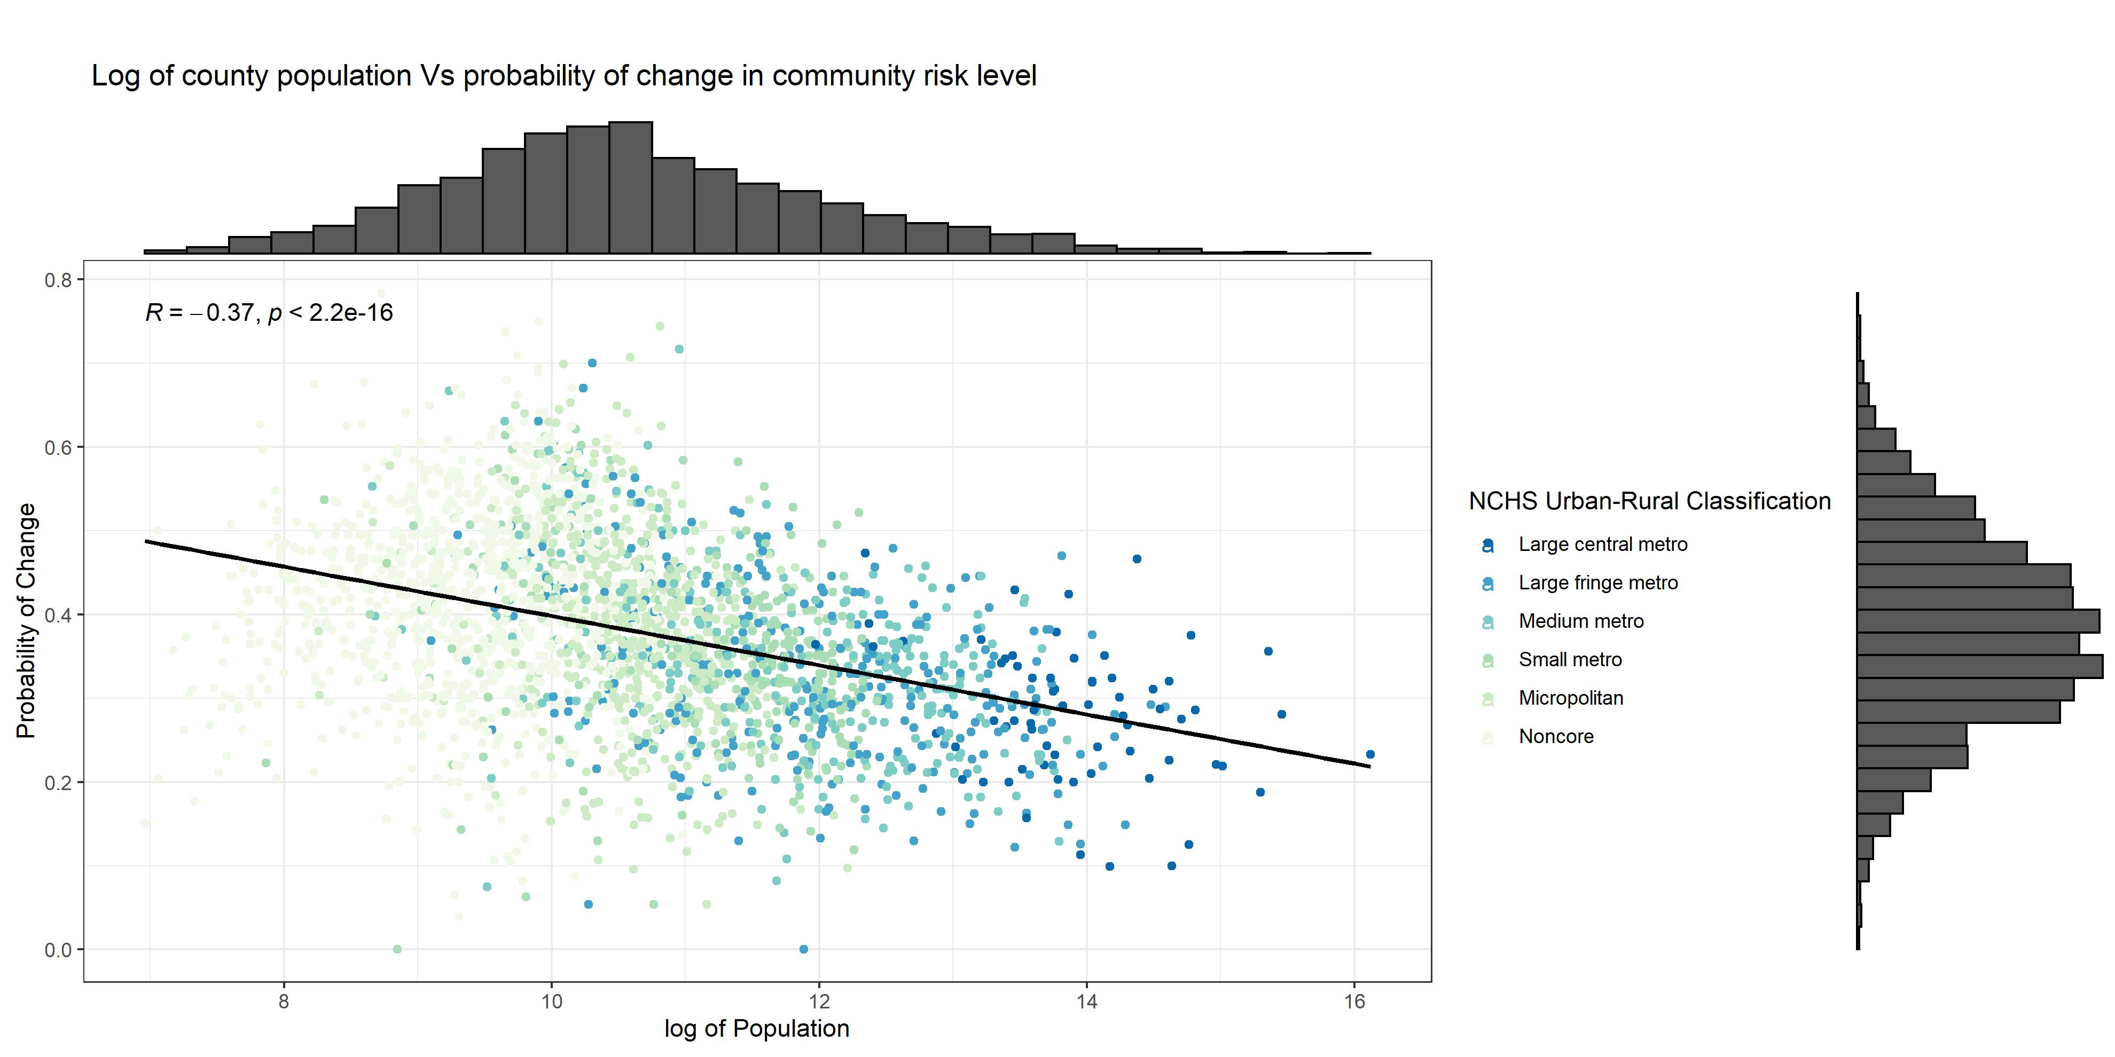

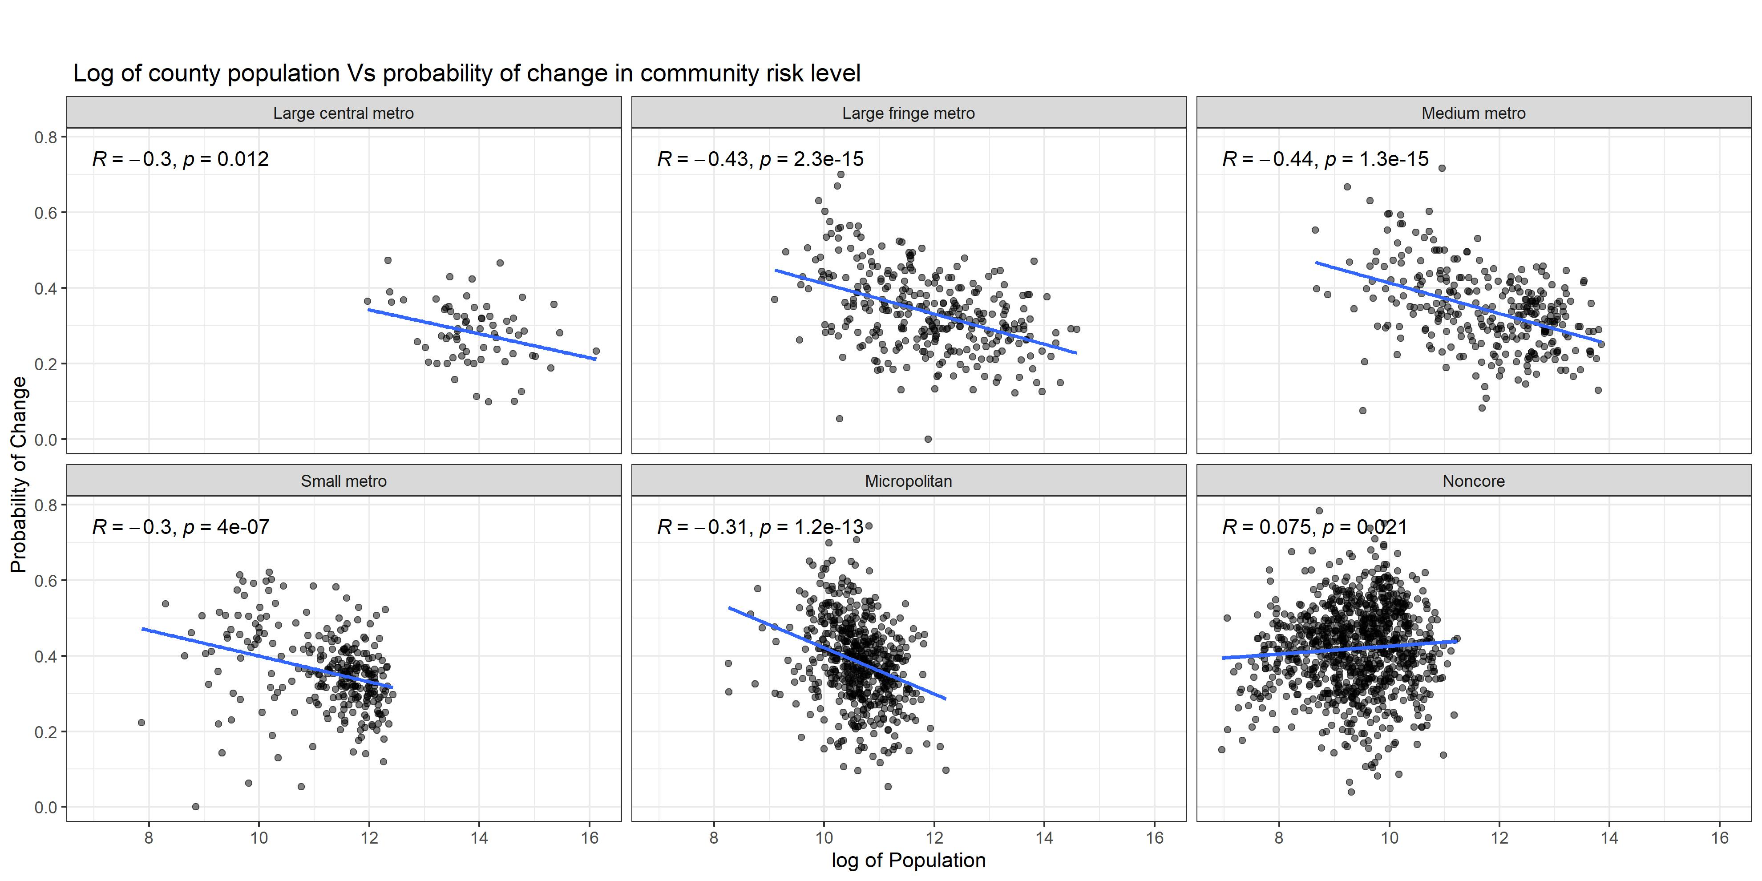

There is a negative correlation (R = -0.39) between population and the rate of change in risk level in counties. So we expect that increasing the county’s population will decrease the rate of change in risk level. However, this correlation is not the same in all NCHS Urban-Rural categories; in the “Noncore” NCHS groups, the correlation is positive (R = 0.082), which means in these counties, we expect the rate of change to increase if the population increase.

# The association between the Number of Hospitals and the rate of change in community risk level

The “Number of hospitals” is the total number of hospital with available data in each county.

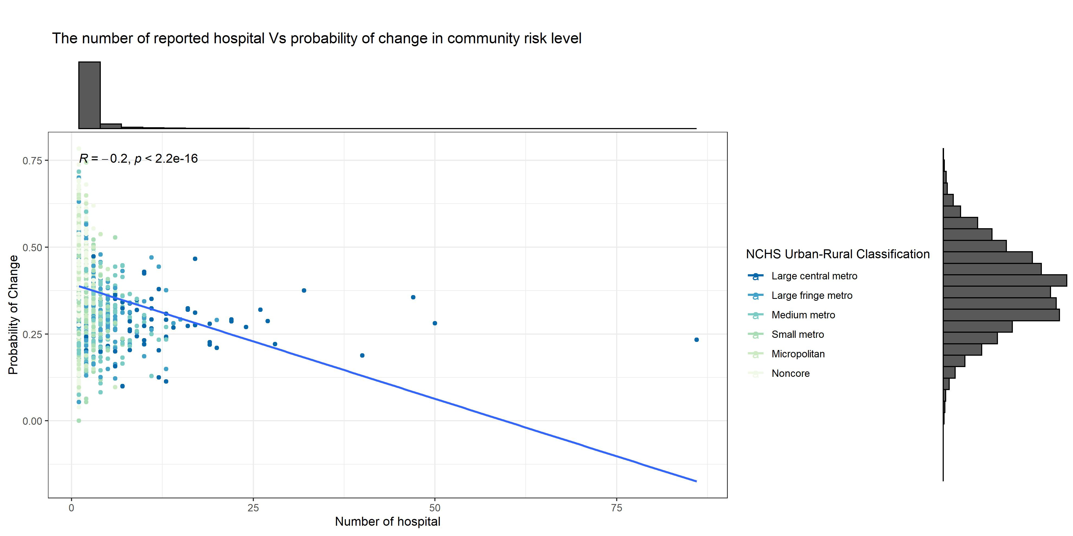

We used log transformation for the number of hospital in each county.

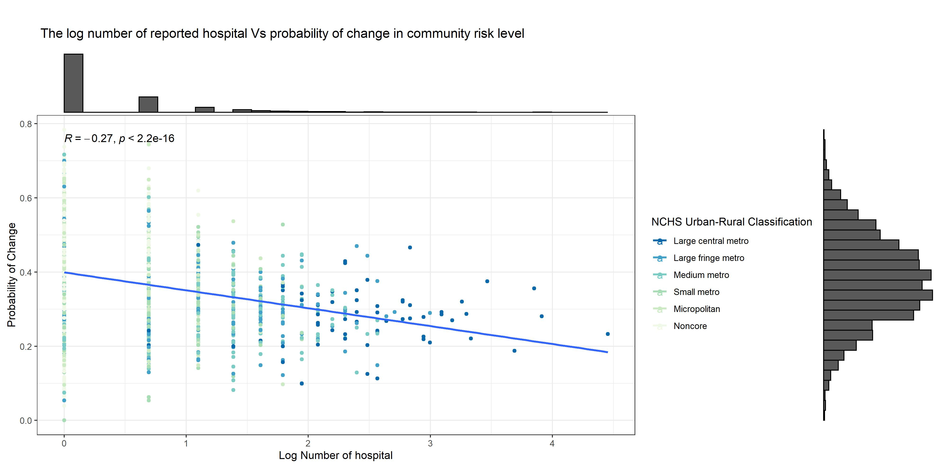 There is a negative correlation (R = -0.28) between the log number of hospitals and the rate of change in risk level. So we expect that increasing the number of hospitals will decrease the rate of change in risk level.

# The association between the Number of Hospitals per 100000 and the rate of change in community risk level

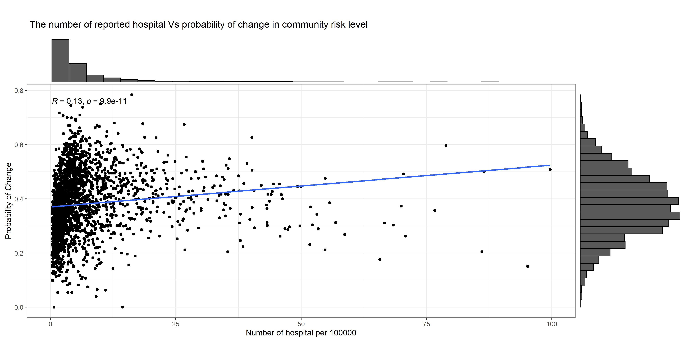

We used log transformation for the number of hospital in each county.

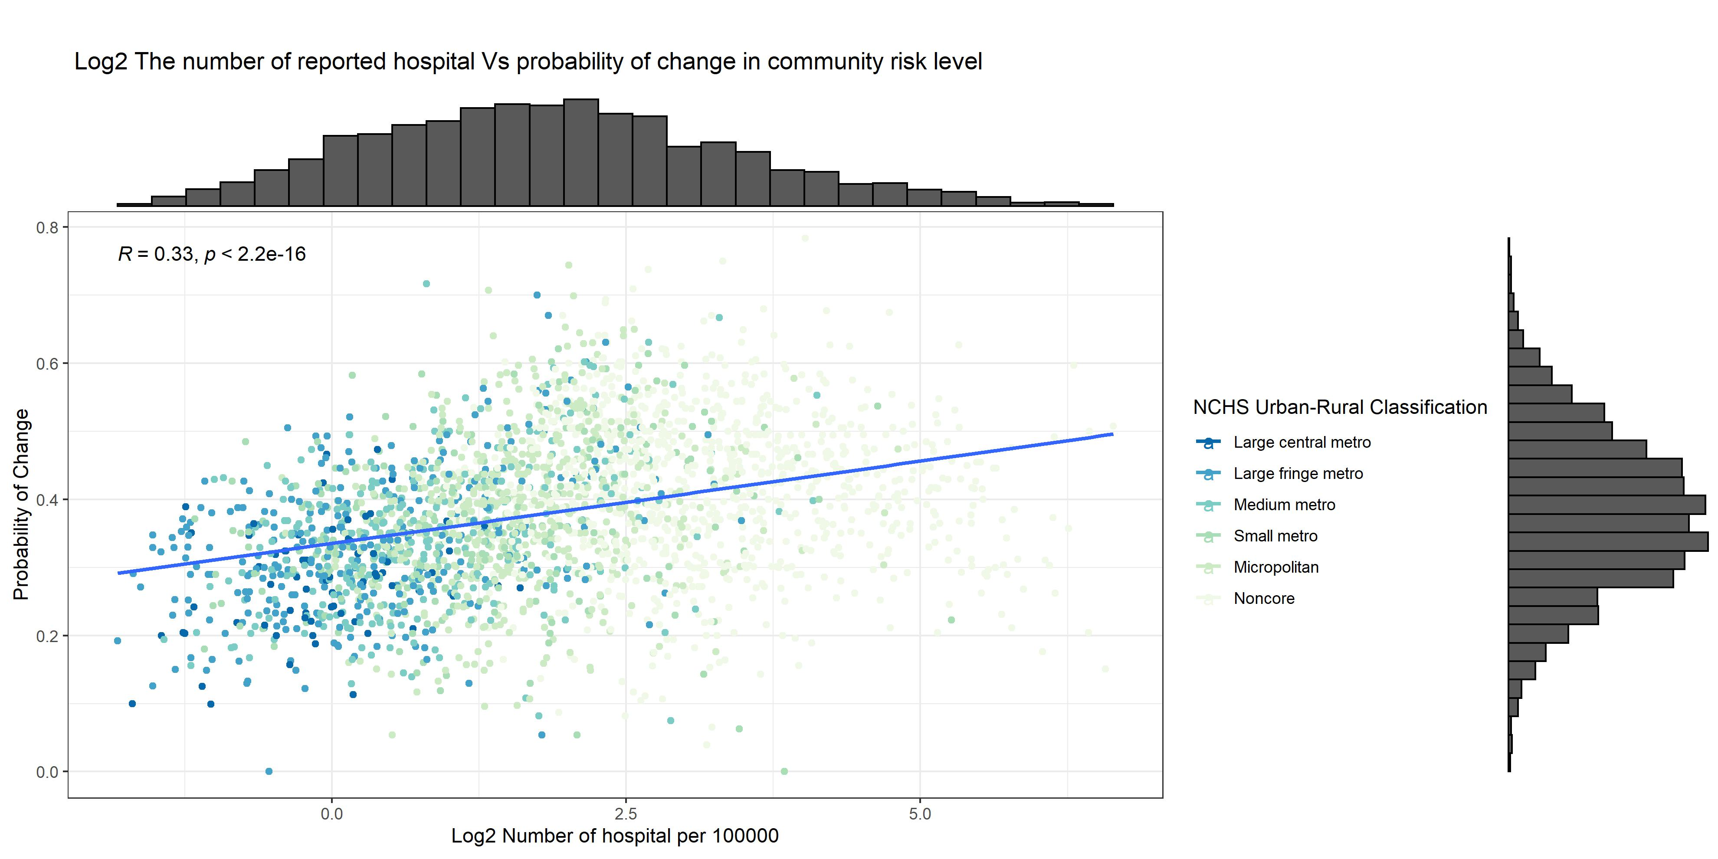

There is a positive correlation (R = 0.35) between the log2 of the number of hospitals per 100000 persons and the rate of change in risk level, which is not what we expect from preview analysis. So we will investigate the association between the number of hospitals per 100000 persons and the population in each county.

# The association between the Number of Hospitals per 100000 persons and the the population

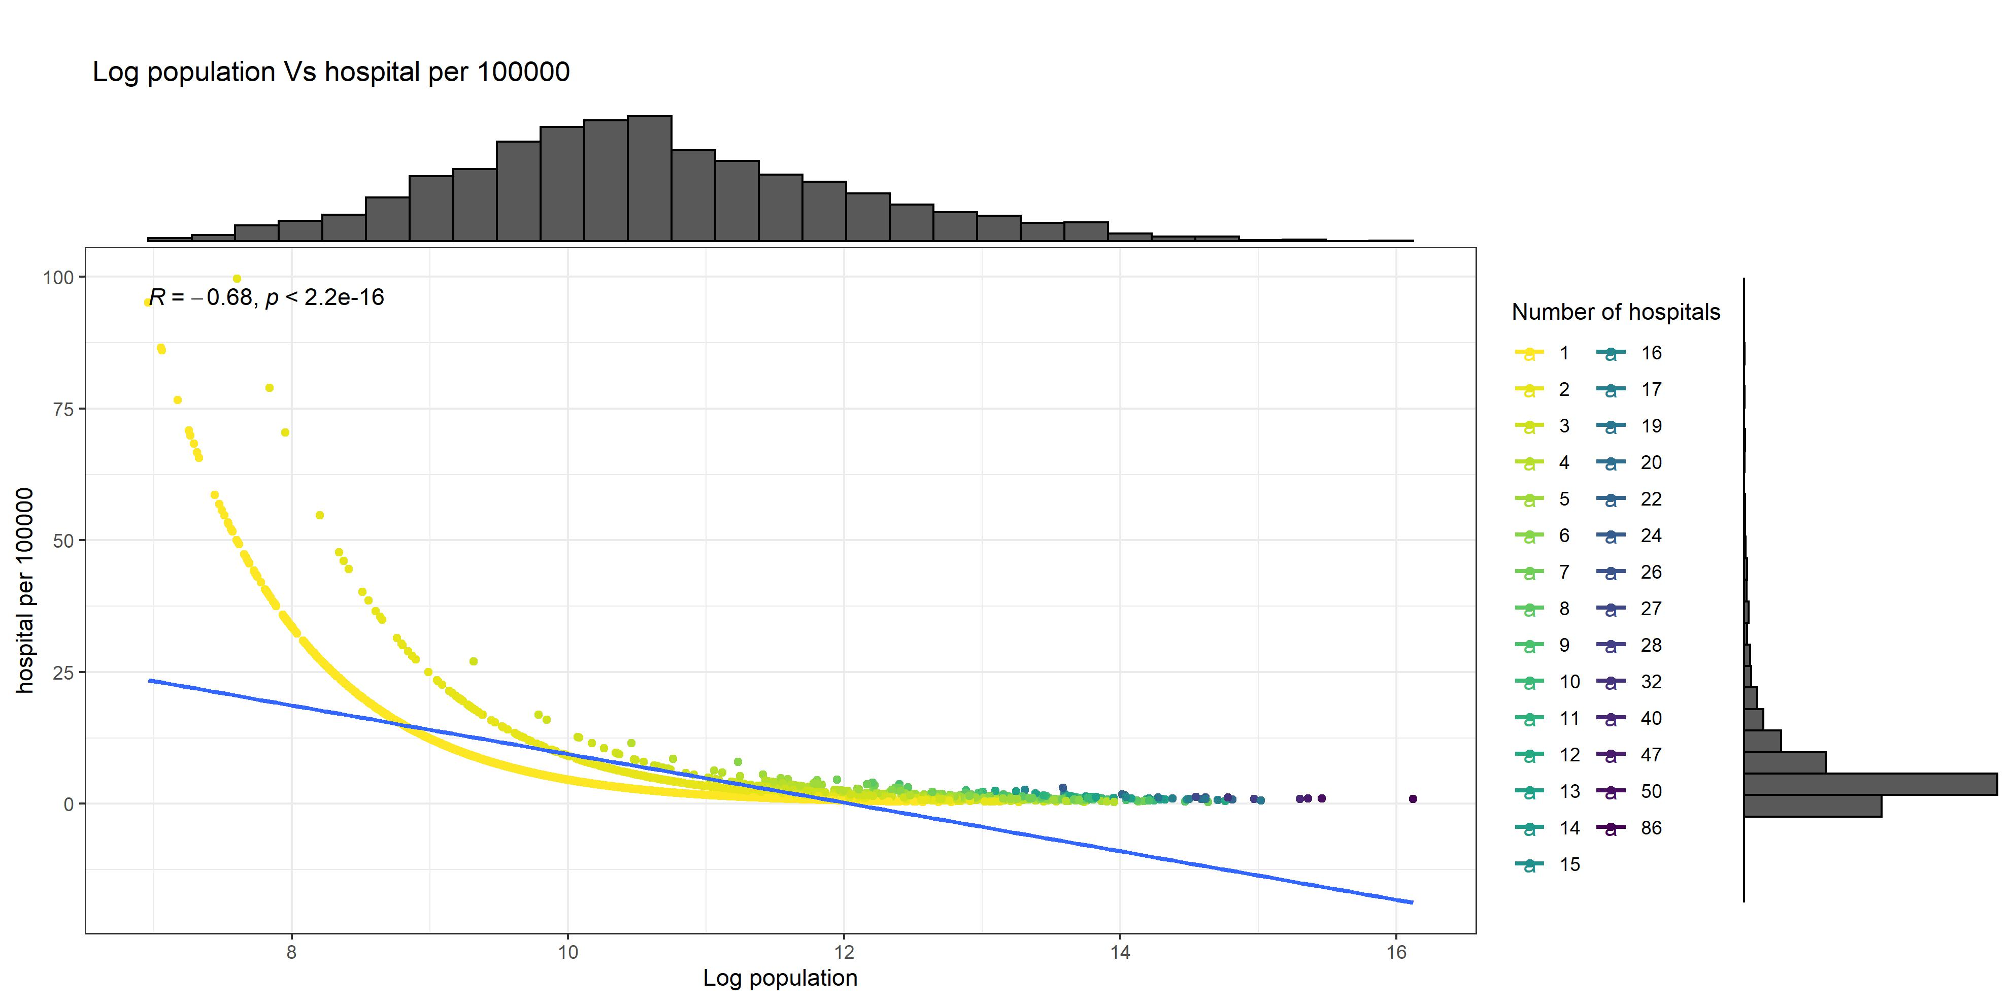

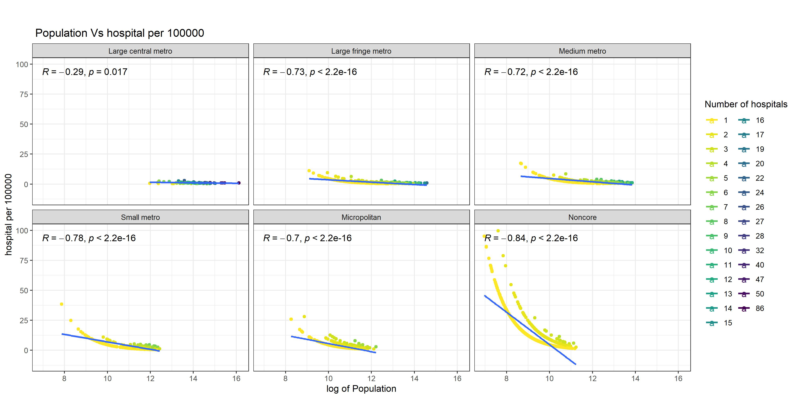

As we can see, there is a negative correlation (R = -0.68) between the hospitals per 100000 persons and the log of the population at the county level. Therefore in the counties with less population and fewer hospitals, we expect a greater hospital per 100000 person value. Also, there is a more negative correlation in “Noncore” counties compared to the other groups.

# clarification

### beds occupancy data at the hospital level

We divide the average number of beds used by covid-19 patients in the last seven days by the total number of beds to compute the percent of staffed inpatient beds occupied by COVID-19. We also add the number of pediatric and adult patients with confirmed COVID-19 admitted in the last seven days and multiply it by 100000 divided by the county population to compute the admissions per 100,000.

### consistency in three-week intervals

For consistency in three-week intervals in a given week, we look at a county’s last two weeks’ risk levels, and if all three weeks have the same risk level, we consider that county consistent at that specific week. Therefore a given week is included in three different “3-week periods.”

### rate of change

The rate of change was defined as the ratio of the total number of weeks that their risk level changed compared to the previous week over the total number of available weeks between 2020-07-31 and 2022-07-29. If a community moved from Low to high in a given week, it would be counted only once in the “rate of change” numerator.

# Population distribution of counties with No availble data

